FAITH Lutheran Church Eleventh Sunday after Pentecost
4241 Williamson Road P.O. 242 August 16, 2020
Bridgeport, MI 48722

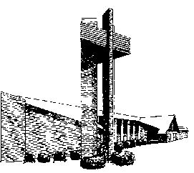

Confession and Absolution
LSB 981 To Your Temple, Lord, I Come
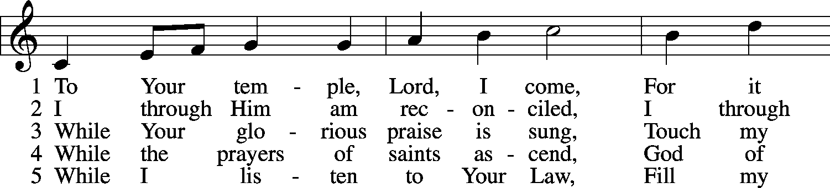
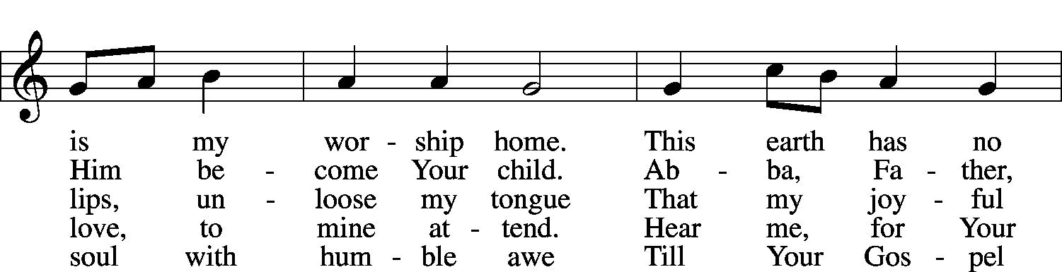
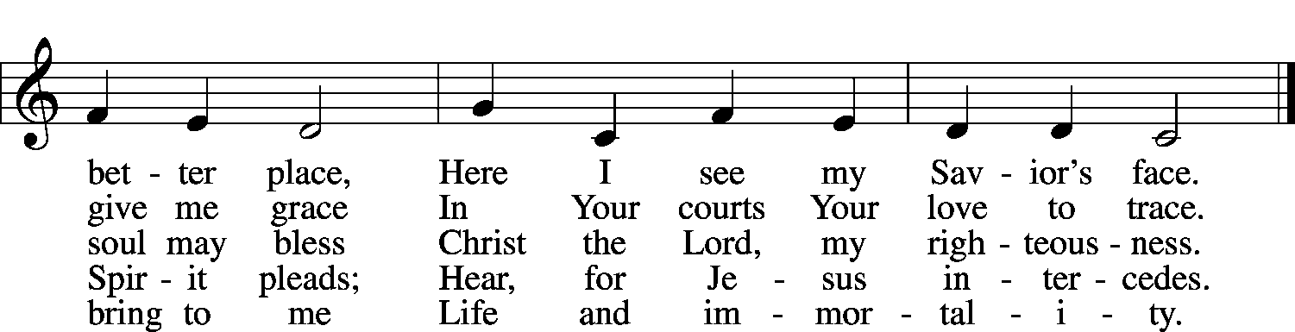

6 While Your ministers proclaim
Peace and pardon in Your name,
Through their voice, by faith, may I
Hear You speaking from the sky.

7 From Your house when I return,
May my heart within me burn,
And at evening let me say,
“I have walked with God today.”
Public domain

Stand
The sign of the cross may be made by all in remembrance of their Baptism.
P In the name of the Father and of the T Son and of the Holy Spirit.
C Amen.

P If we say we have no sin, we deceive ourselves, and the truth is not in us.
C But if we confess our sins, God, who is faithful and just, will forgive our sins and cleanse us from all unrighteousness.

Kneel/Stand
Silence for reflection on God's Word and for self-examination.
P Let us then confess our sins to God our Father.
C Most merciful God, we confess that we are by nature sinful and unclean. We have sinned against You in thought, word, and deed, by what we have done and by what we have left undone. We have not loved You with our whole heart; we have not loved our neighbors as ourselves. We justly deserve Your present and eternal punishment. For the sake of Your Son, Jesus Christ, have mercy on us. Forgive us, renew us, and lead us, so that we may delight in Your will and walk in Your ways to the glory of Your holy name. Amen.
P Almighty God in His mercy has given His Son to die for you and for His sake forgives you all your sins. As a called and ordained servant of Christ, and by His authority, I therefore forgive you all your sins in the name of the Father and of the T Son and of the Holy Spirit.
C Amen.

Stand
Service of the Word
Introit Ps. 28:1–2, 6–7; antiphon: Ps. 28:8
The Lord is the strength of his people;
he is the saving refuge of his anointed.
To you, O Lord, I call; my rock, be not deaf to me,
lest, if you be silent to me, I become like those who go down to the pit.
Hear the voice of my pleas for mercy, when I cry to you for help,
when I lift up my hands toward your most holy sanctuary.
Blessèd be the Lord!
For he has heard the voice of my pleas for mercy.
The Lord is my strength and my shield; in him my heart trusts, and I am helped;
my heart exults, and with my song I give thanks to him.
Glory be to the Father and to the Son and to the Holy Spirit;
as it was in the beginning, is now, and will be forever. Amen.
The Lord is the strength of his people;
he is the saving refuge of his anointed.

Kyrie LSB 152
P In peace let us pray to the Lord.
C Lord, have mercy.
P For the peace from above and for our salvation let us pray to the Lord.
C Lord, have mercy.
P For the peace of the whole world, for the well-being of the Church of God, and for the unity of all let us pray to the Lord.
C Lord, have mercy.
P For this holy house and for all who offer here their worship and praise let us pray to the Lord.
C Lord, have mercy.
P Help, save, comfort, and defend us, gracious Lord.
C Amen.

This Is the Feast LSB 155
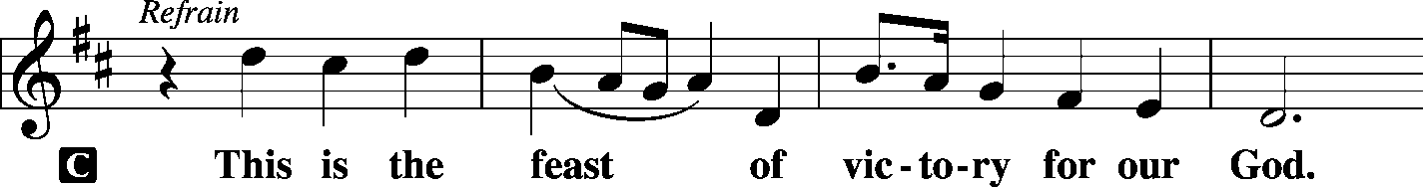
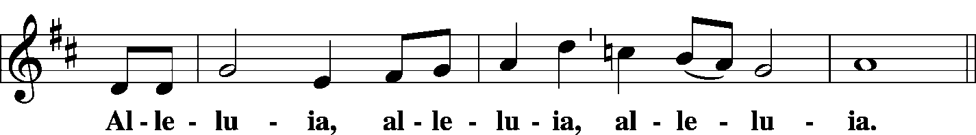
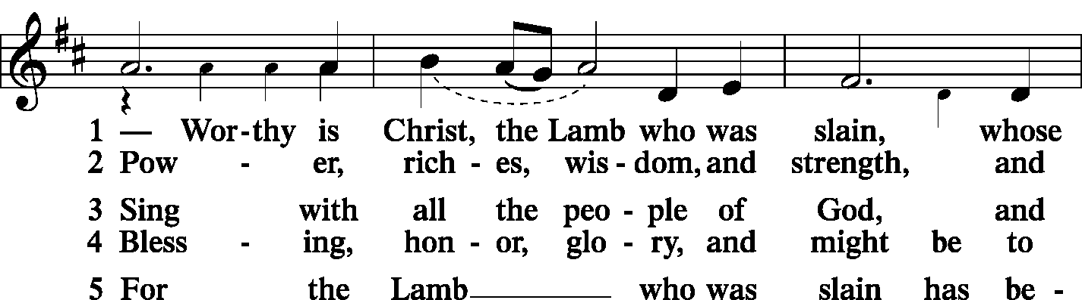
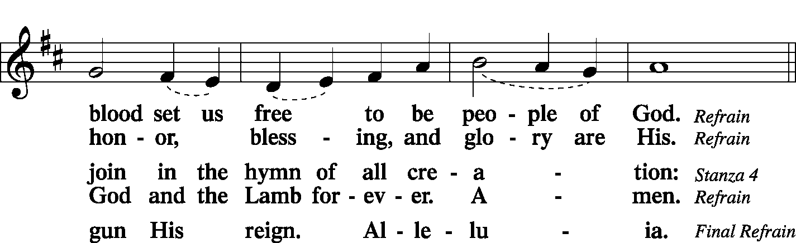
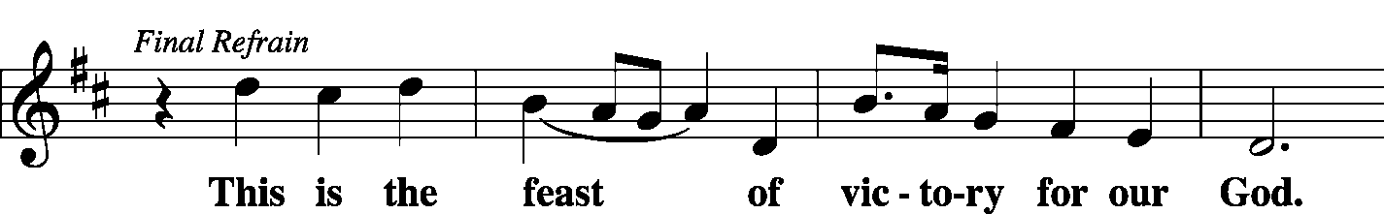
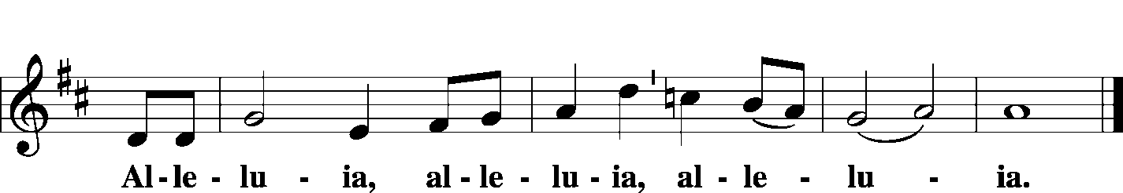

Salutation and Collect of the Day
P The Lord be with you.
C And also with you.
P Let us pray.
Almighty and everlasting Father, You give Your children many blessings even though we are undeserving. In every trial and temptation grant us steadfast confidence in Your loving-kindness and mercy; through Jesus Christ, Your Son, our Lord, who lives and reigns with You and the Holy Spirit, one God, now and forever.
C Amen.

Sit
Old Testament Reading Isaiah 56:1, 6–8
¹Thus says the Lord:
“Keep justice, and do righteousness,
for soon my salvation will come,
and my deliverance be revealed.
⁶“And the foreigners who join themselves to the Lord,
to minister to him, to love the name of the Lord,
and to be his servants,
everyone who keeps the Sabbath and does not profane it,
and holds fast my covenant—
⁷these I will bring to my holy mountain,
and make them joyful in my house of prayer;
their burnt offerings and their sacrifices
will be accepted on my altar;
for my house shall be called a house of prayer
for all peoples.”
⁸The Lord God,
who gathers the outcasts of Israel, declares,
“I will gather yet others to him
besides those already gathered.”
A This is the Word of the Lord.
C Thanks be to God.

Psalm Psalm 67 (antiphon: v. 5)
A May God be gracious to us and bless us
C and make his face to shine upon us,
A that your way may be known on earth,
C your saving power among all nations.
A Let the peoples praise you, O God;
C let all the peoples praise you!
A Let the nations be glad and sing for joy,
C for you judge the peoples with equity
and guide the nations upon earth.
A Let the peoples praise you, O God;
C let all the peoples praise you!
A The earth has yielded its increase;
C God, our God, shall bless us.
A God shall bless us;
C let all the ends of the earth fear him!
C Glory be to the Father and to the Son and to the Holy Spirit;
as it was in the beginning, is now, and will be forever. Amen.

Epistle Romans 11:1–2a, 13–15, 28–32
¹I ask, then, has God rejected his people? By no means! For I myself am an Israelite, a descendant of Abraham, a member of the tribe of Benjamin. ²God has not rejected his people whom he foreknew. Do you not know what the Scripture says of Elijah, how he appeals to God against Israel?
¹³Now I am speaking to you Gentiles. Inasmuch then as I am an apostle to the Gentiles, I magnify my ministry ¹⁴in order somehow to make my fellow Jews jealous, and thus save some of them. ¹⁵For if their rejection means the reconciliation of the world, what will their acceptance mean but life from the dead?
²⁸As regards the gospel, they are enemies of God for your sake. But as regards election, they are beloved for the sake of their forefathers. ²⁹For the gifts and the calling of God are irrevocable. ³⁰Just as you were at one time disobedient to God but now have received mercy because of their disobedience,
³¹1so they too have now been disobedient in order that by the mercy shown to you they also may now receive mercy.
³²For God has consigned all to disobedience, that he may have mercy on all.

A This is the Word of the Lord.
C Thanks be to God.

Stand
Alleluia and Verse LSB 156
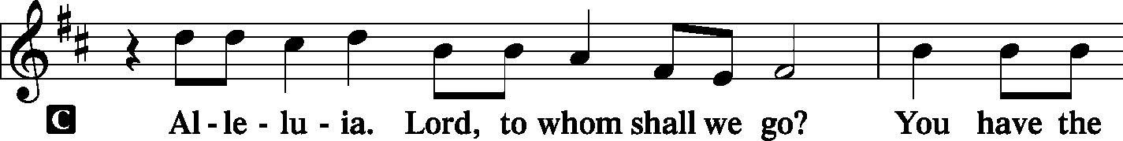
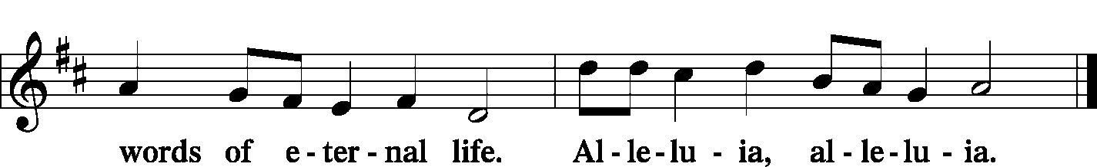

Holy Gospel Matthew 15:21–28
P The Holy Gospel according to St. Matthew, the fifteenth chapter.
C Glory to You, O Lord.

²¹ Jesus went away from there and withdrew to the district of Tyre and Sidon.
²²And behold, a Canaanite woman from that region came out and was crying, “Have mercy on me, O Lord, Son of David; my daughter is severely oppressed by a demon.” ²³But he did not answer her a word. And his disciples came and begged him, saying, “Send her away, for she is crying out after us.” ²⁴He answered, “I was sent only to the lost sheep of the house of Israel.” ²⁵But she came and knelt before him, saying, “Lord, help me.” ²⁶And he answered, “It is not right to take the children’s bread and throw it to the dogs.” ²⁷She said, “Yes, Lord, yet even the dogs eat the crumbs that fall from their masters’ table.” ²⁸Then Jesus answered her, “O woman, great is your faith! Be it done for you as you desire.” And her daughter was healed instantly.

P This is the Gospel of the Lord.
C Praise to You, O Christ.

Nicene Creed
C I believe in one God,
the Father Almighty,
maker of heaven and earth
and of all things visible and invisible.

And in one Lord Jesus Christ,
the only-begotten Son of God,
begotten of His Father before all worlds,
God of God, Light of Light,
very God of very God,
begotten, not made,
being of one substance with the Father,
by whom all things were made;
who for us men and for our salvation came down from heaven
and was incarnate by the Holy Spirit of the virgin Mary
and was made man;
and was crucified also for us under Pontius Pilate.
He suffered and was buried.
And the third day He rose again according to the Scriptures
and ascended into heaven
and sits at the right hand of the Father.
And He will come again with glory to judge both the living and the dead,
whose kingdom will have no end.

And I believe in the Holy Spirit,
the Lord and giver of life,
who proceeds from the Father and the Son,
who with the Father and the Son together is worshiped and glorified,
who spoke by the prophets.
And I believe in one holy Christian and apostolic Church,
I acknowledge one Baptism for the remission of sins,
and I look for the resurrection of the dead
and the life T of the world to come. Amen.

Sit

Kidz’ Word
LSB 510 A Multitude Comes from the East and the West
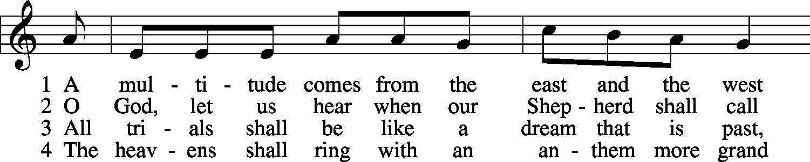
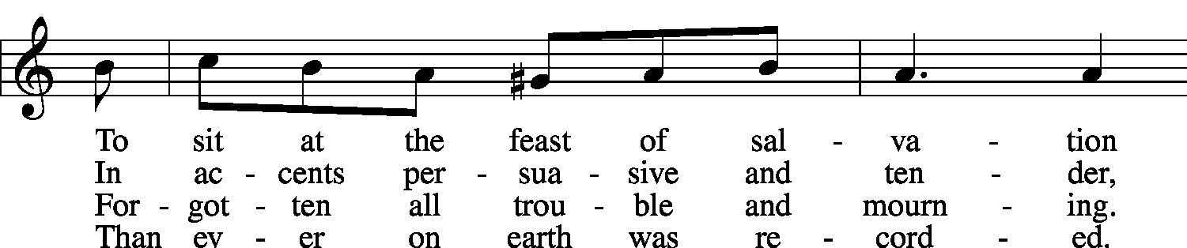
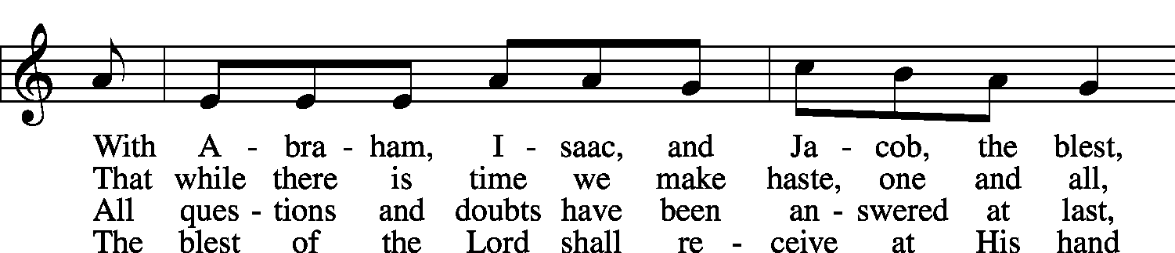
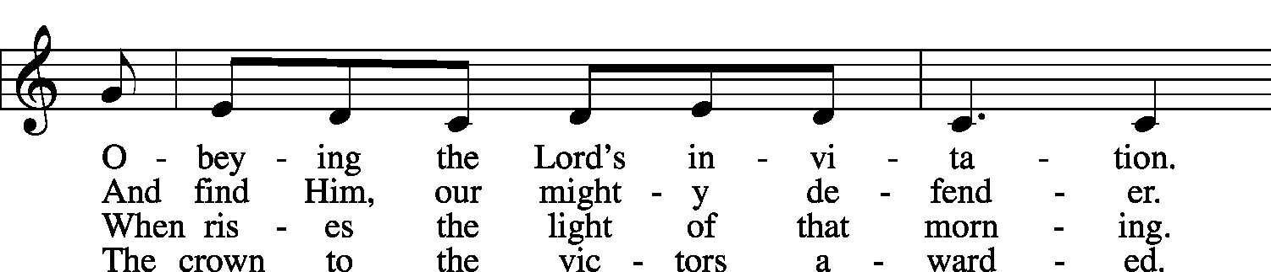
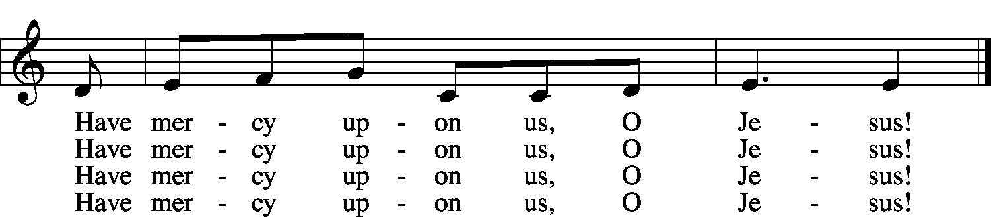
Public domain

Sermon
Stand
Prayer of the Church

Offertory LSB 159
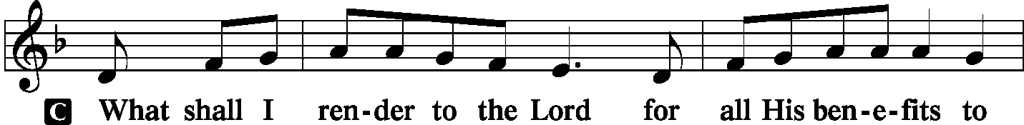
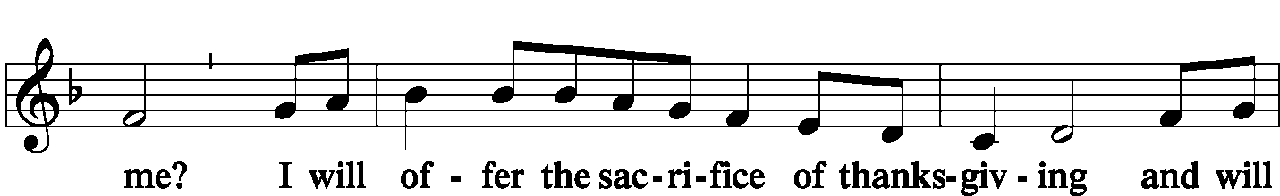
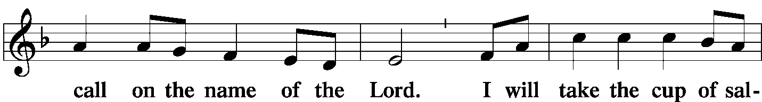
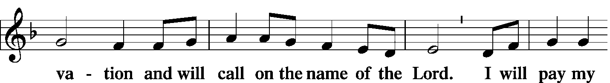
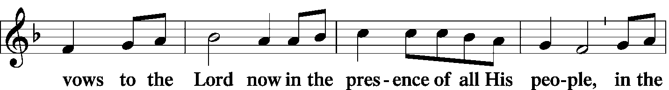
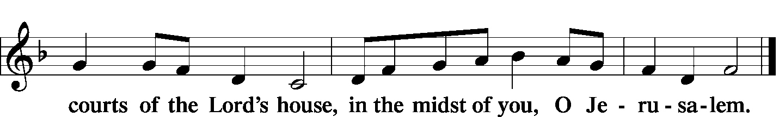
Service of the Sacrament
Preface LSB 160
P The Lord be with you.
C And also with you.
P Lift up your hearts.
C We lift them to the Lord.
P Let us give thanks to the Lord our God.
C It is right to give Him thanks and praise.
P It is truly good, right, and salutary . . . evermore praising You and saying:

Sanctus LSB 161
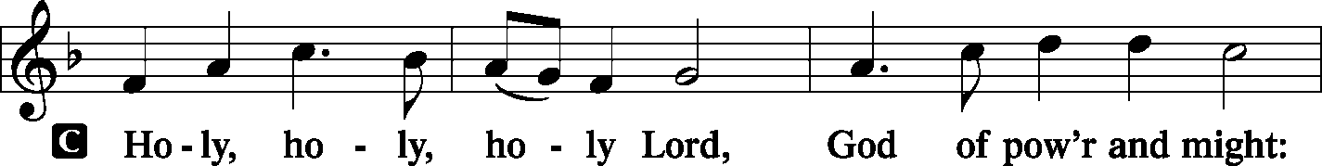
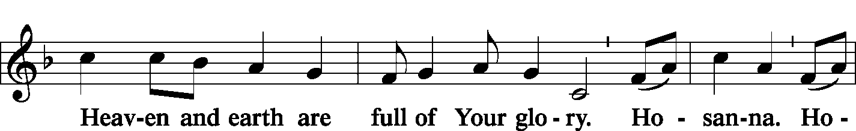
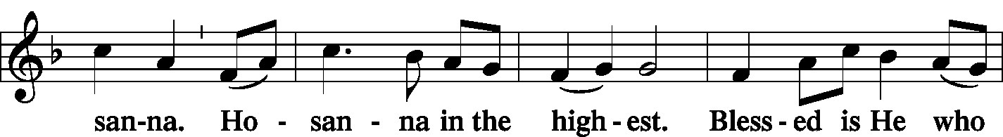
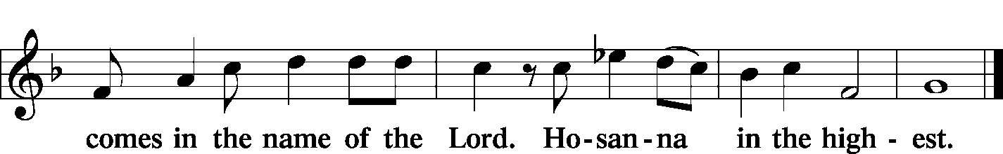

Prayer of Thanksgiving LSB 161
P Blessed are You, Lord of heaven and earth…. one God, now and forever.
C Amen.
Lord's Prayer LSB 162
P Lord, remember us in Your kingdom and teach us to pray:
C Our Father who art in heaven,
hallowed be Thy name,
Thy kingdom come,
Thy will be done on earth as it is in heaven;
give us this day our daily bread;
and forgive us our trespasses as we forgive those who trespass against us;
and lead us not into temptation,
but deliver us from evil.
For Thine is the kingdom and the power and the glory forever and ever. Amen.

The Words of Our Lord LSB 162
Pax Domini LSB 163
P The peace of the Lord be with you always.
C Amen.

Agnus Dei LSB 163
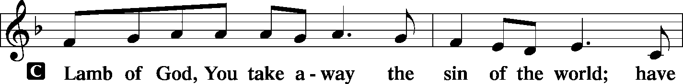
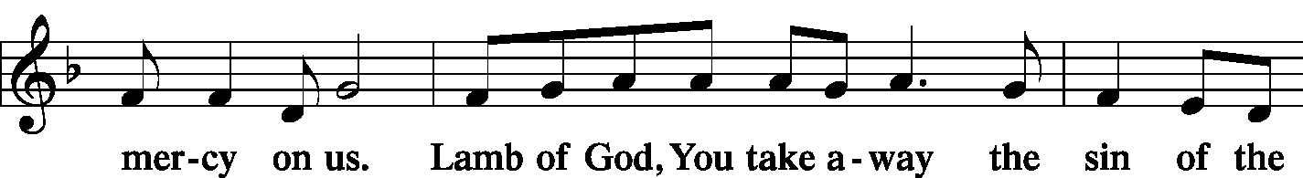
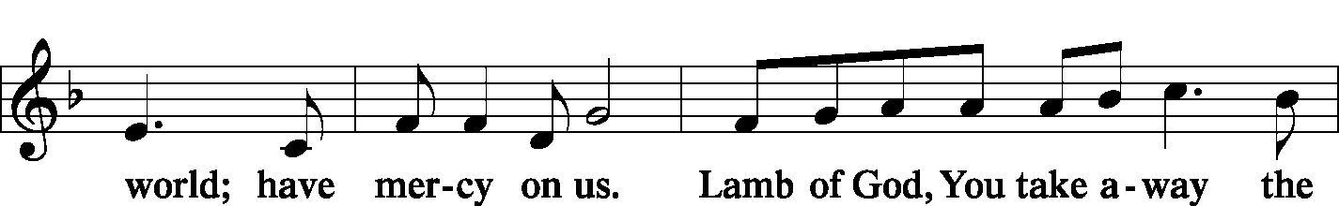
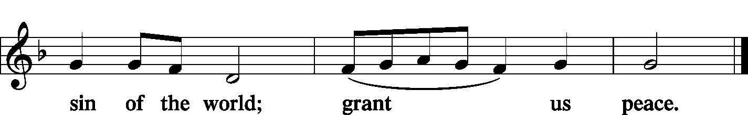

Sit
Distribution
LSB 570 Just as I Am, without One Plea
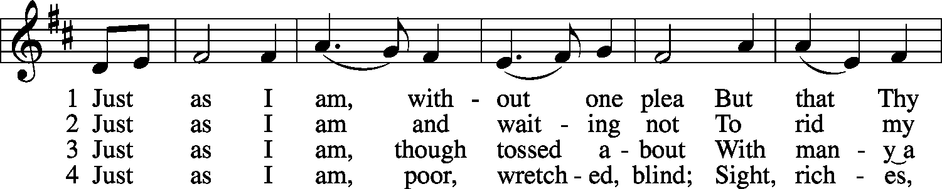
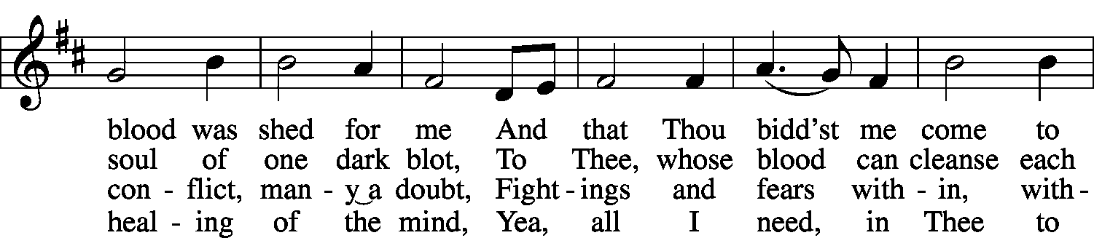
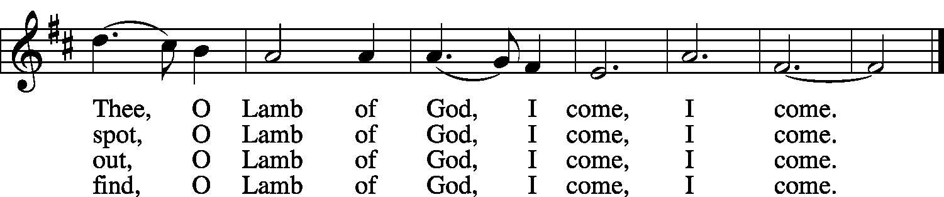

5 Just as I am, Thou wilt receive,
Wilt welcome, pardon, cleanse, relieve;
Because Thy promise I believe,
O Lamb of God, I come, I come.

6 Just as I am; Thy love unknown
Has broken ev’ry barrier down;
Now to be Thine, yea, Thine alone,
O Lamb of God, I come, I come.
Public domain

LSB 619 Thy Body, Given for Me, O Savior
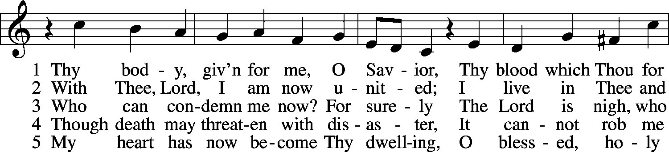
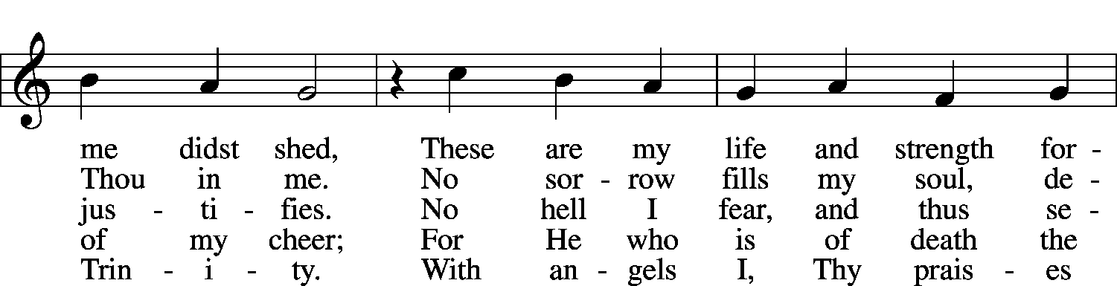
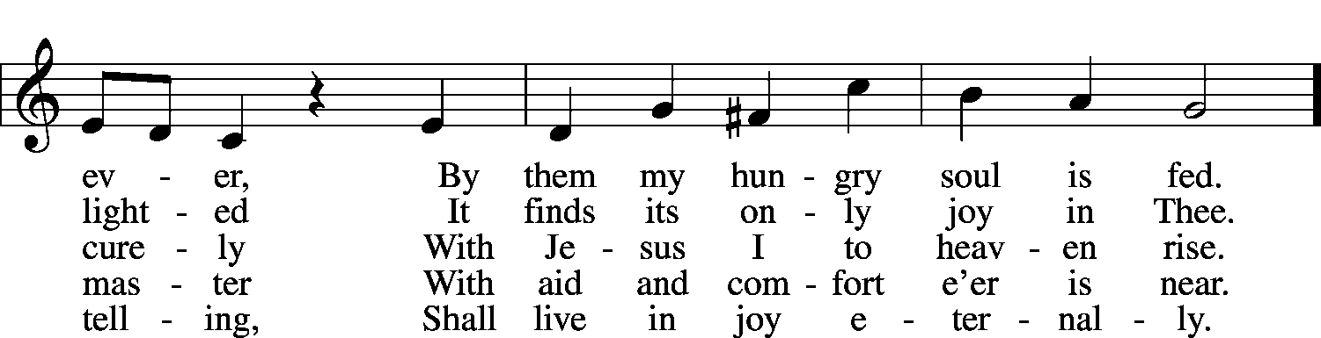
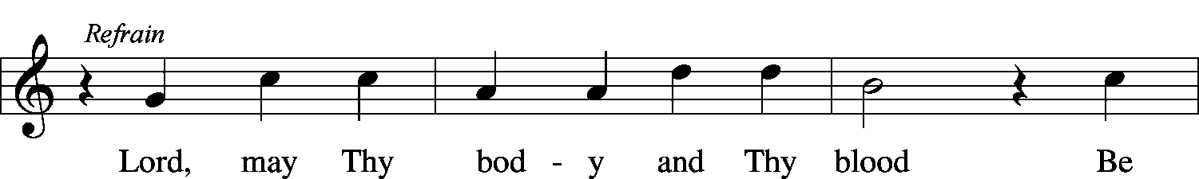
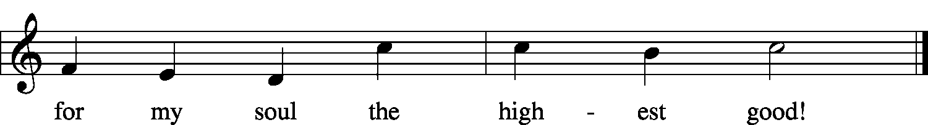
© 1941 Concordia Publishing House. Used by permission: LSB Hymn License .NET, no. 100011552.
Public domain

Stand
Thank the Lord LSB 164
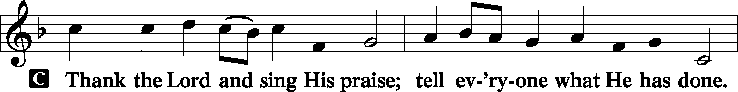
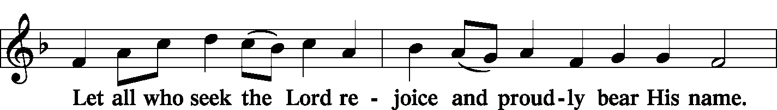
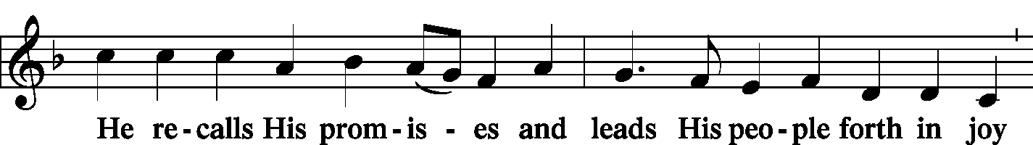
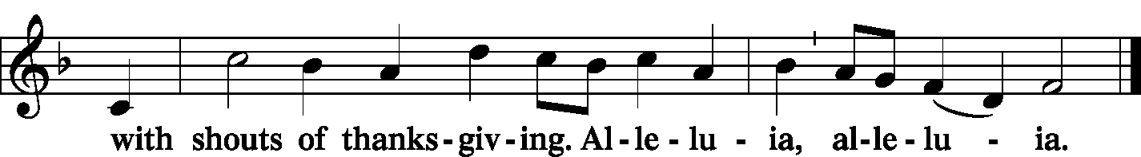

Post-Communion Collect
A Let us pray.
We give thanks to You… one God, now and forever.
C Amen.

Benediction LSB 166
P The Lord bless you and keep you.
The Lord make His face shine on you
and be gracious to you.
The Lord look upon you with favor and T give you peace.
C Amen.

922 sts. 3–4 Go, My Children, with My Blessing
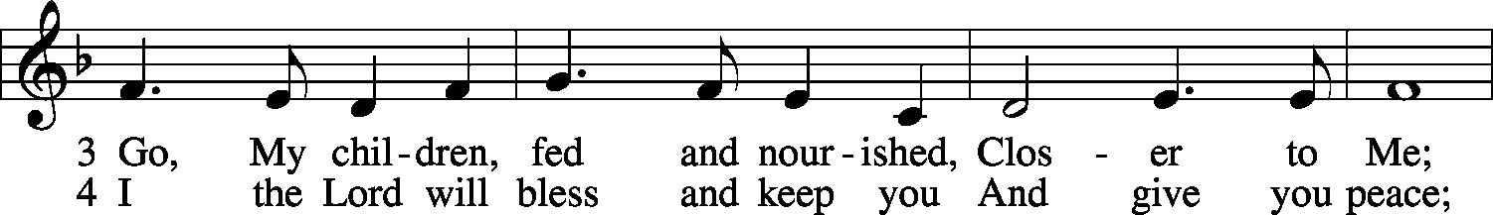
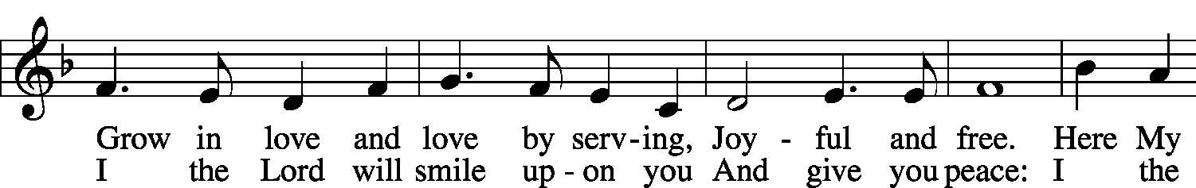
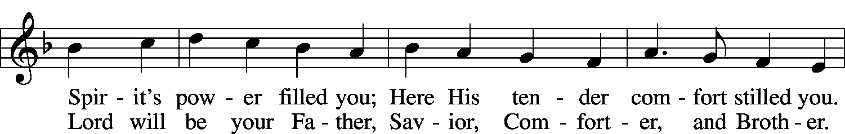
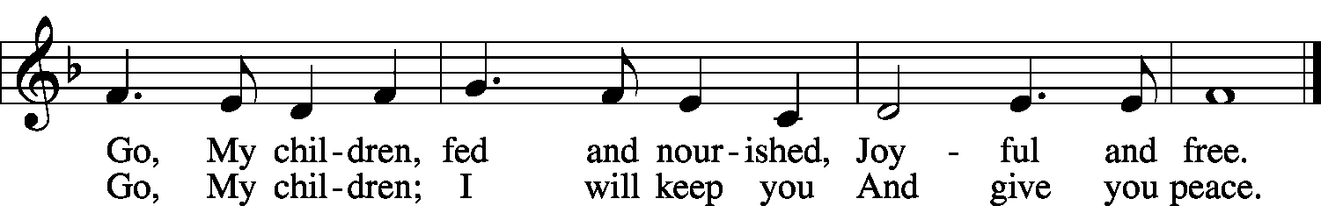
© 1983 Concordia Publishing House. Used by permission: LSB Hymn License .NET, no. 100011552.
Public domain

Acknowledgments
Unless otherwise indicated, all scripture quotations are from The Holy Bible, English Standard Version, copyright © 2001 by Crossway Bibles, a division of Good News Publishers. Used by permission. All rights reserved.
Created by Lutheran Service Builder © 2006 Concordia Publishing House.

