FAITH Lutheran Church The Day of Pentecost
4241 Williamson Road P.O. 242 May 31, 2020
Bridgeport, MI 48722

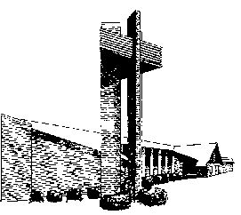

Confession and Absolution
LSB 913 O Holy Spirit, Enter In
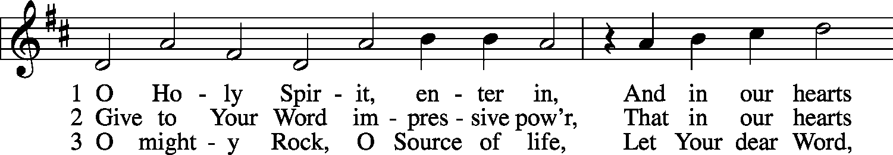
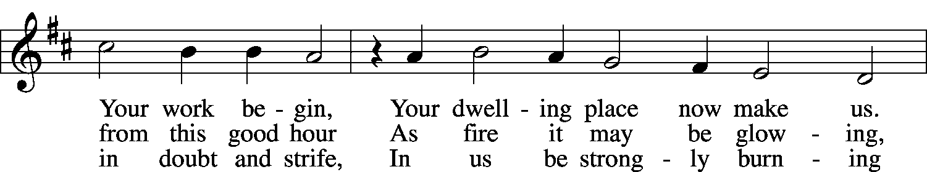
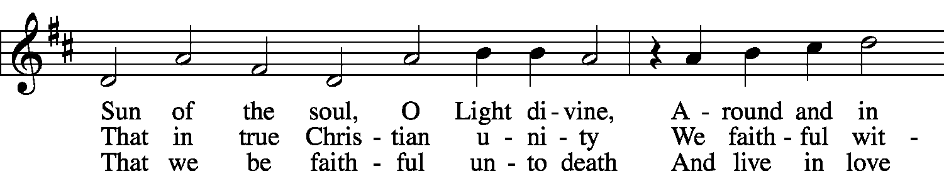
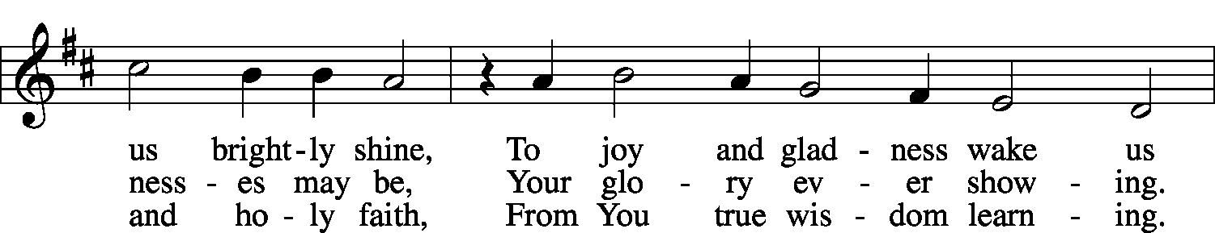
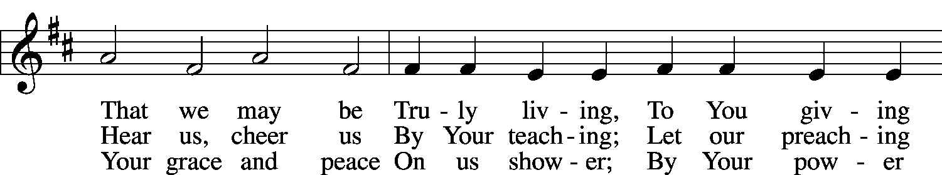
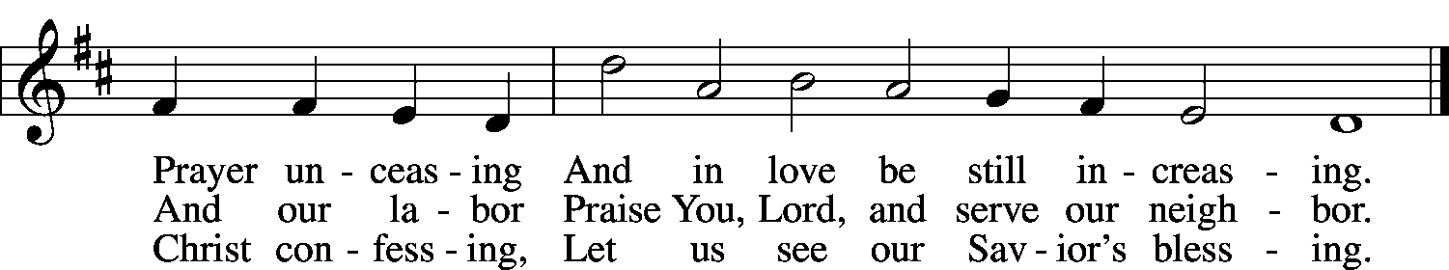
Public domain

Stand
The sign of the cross may be made by all in remembrance of their Baptism.
P In the name of the Father and of the T Son and of the Holy Spirit.
C Amen.

P If we say we have no sin, we deceive ourselves, and the truth is not in us.
C But if we confess our sins, God, who is faithful and just, will forgive our sins and cleanse us from all unrighteousness.

Kneel/Stand
Silence for reflection on God's Word and for self-examination.
P Let us then confess our sins to God our Father.
C Most merciful God, we confess that we are by nature sinful and unclean. We have sinned against You in thought, word, and deed, by what we have done and by what we have left undone. We have not loved You with our whole heart; we have not loved our neighbors as ourselves. We justly deserve Your present and eternal punishment. For the sake of Your Son, Jesus Christ, have mercy on us. Forgive us, renew us, and lead us, so that we may delight in Your will and walk in Your ways to the glory of Your holy name. Amen.
P Almighty God in His mercy has given His Son to die for you and for His sake forgives you all your sins. As a called and ordained servant of Christ, and by His authority, I therefore forgive you all your sins in the name of the Father and of the T Son and of the Holy Spirit.
C Amen.

Stand
Service of the Word
Introit Ps. 104:24, 27–28, 30; antiphon: Liturgical Text
Come, Holy Spirit, fill the hearts of the faithful,
and kindle in them the fire of your love. Alleluia.
O Lord, how manifold are your works! In wisdom have you made them all;
the earth is full of your creatures.
These all look to you,
to give them their food in due season.
When you give it to them, they gather it up;
when you open your hand, they are filled with good things.
When you send forth your Spirit, they are created,
and you renew the face of the ground.
Glory be to the Father and to the Son and to the Holy Spirit;
as it was in the beginning, is now, and will be forever. Amen.
Come, Holy Spirit, fill the hearts of the faithful,
and kindle in them the fire of your love. Alleluia.

Kyrie LSB 152
P In peace let us pray to the Lord.
C Lord, have mercy.
P For the peace from above and for our salvation let us pray to the Lord.
C Lord, have mercy.
P For the peace of the whole world, for the well-being of the Church of God, and for the unity of all let us pray to the Lord.
C Lord, have mercy.
P For this holy house and for all who offer here their worship and praise let us pray to the Lord.
C Lord, have mercy.
P Help, save, comfort, and defend us, gracious Lord.
C Amen.

Gloria in Excelsis LSB 154
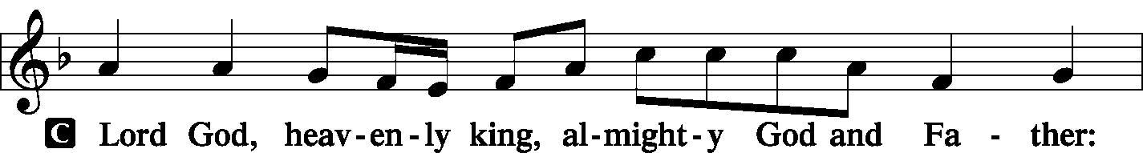
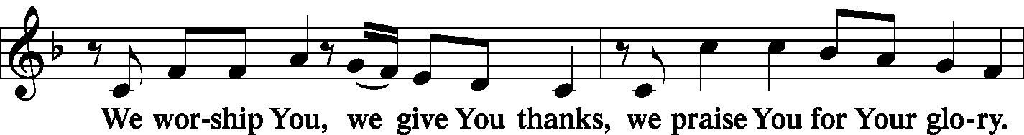
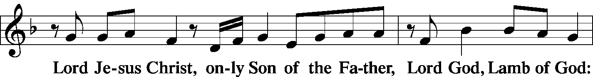
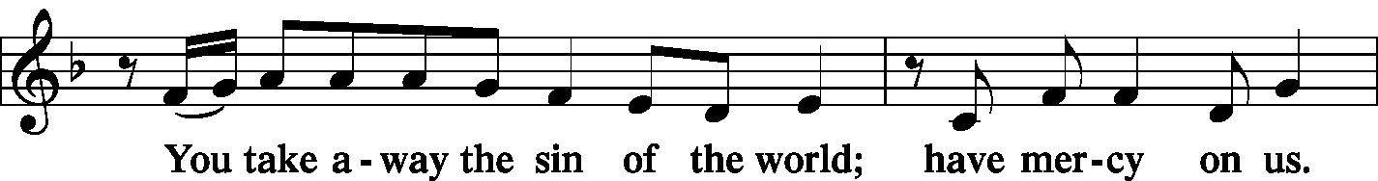
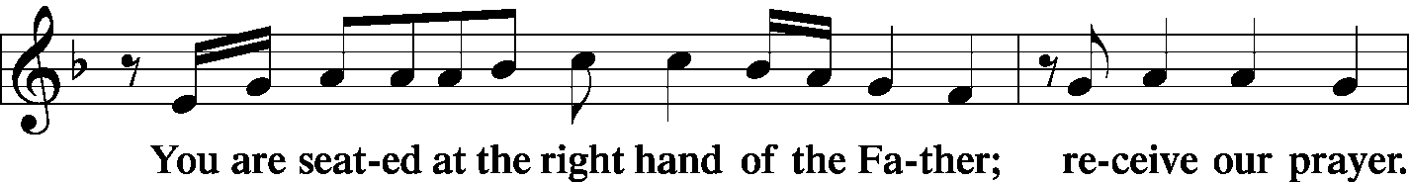
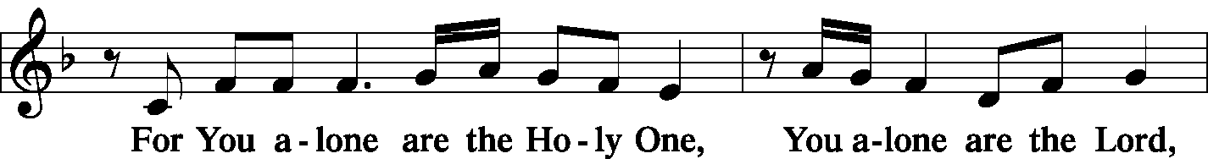
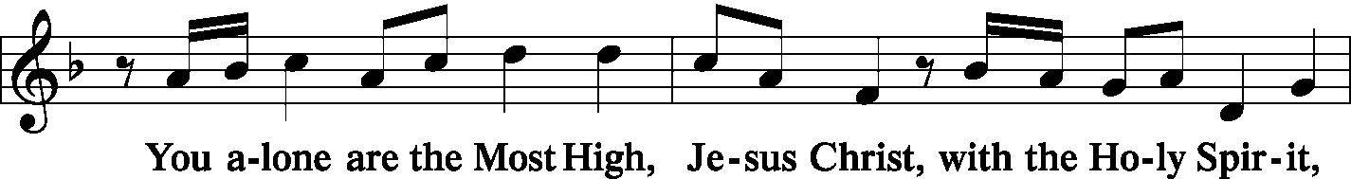
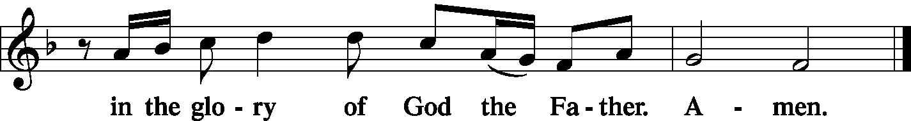

Salutation and Collect of the Day
P The Lord be with you.
C And also with you.
P Let us pray.
O God, on this day You once taught the hearts of Your faithful people by sending them the light of Your Holy Spirit. Grant us in our day by the same Spirit to have a right understanding in all things and evermore to rejoice in His holy consolation; through Jesus Christ, Your Son, our Lord, who lives and reigns with You and the Holy Spirit, one God, now and forever.
C Amen.

Sit
Old Testament Reading Numbers 11:24–30
²⁴So Moses went out and told the people the words of the Lord. And he gathered seventy men of the elders of the people and placed them around the tent. ²⁵Then the Lord came down in the cloud and spoke to him, and took some of the Spirit that was on him and put it on the seventy elders. And as soon as the Spirit rested on them, they prophesied. But they did not continue doing it.
²⁶Now two men remained in the camp, one named Eldad, and the other named Medad, and the Spirit rested on them. They were among those registered, but they had not gone out to the tent, and so they prophesied in the camp. ²⁷And a young man ran and told Moses, “Eldad and Medad are prophesying in the camp.” ²⁸And Joshua the son of Nun, the assistant of Moses from his youth, said, “My lord Moses, stop them.” ²⁹But Moses said to him, “Are you jealous for my sake? Would that all the Lord’s people were prophets, that the Lord would put his Spirit on them!” ³⁰And Moses and the elders of Israel returned to the camp.

A This is the Word of the Lord.
C Thanks be to God.

Psalm Psalm 25:1–15 (antiphon: v. 4)
A To you, O Lord,
C I lift up my soul.
A O my God, in you I trust; let me not be put to shame;
C let not my enemies exult over me.
A Indeed, none who wait for you shall be put to shame;
C they shall be ashamed who are wantonly treacherous.
A Make me to know your ways, O Lord;
C teach me your paths.
A Lead me in your truth and teach me, for you are the God of my salvation;
C for you I wait all the day long.
A Remember your mercy, O Lord, and your steadfast love,
C for they have been from of old.
A Remember not the sins of my youth or my transgressions;
C according to your steadfast love remember me,
for the sake of your goodness, O Lord!
A Good and upright is the Lord;
C therefore he instructs sinners in the way.
A He leads the humble in what is right,
C and teaches the humble his way.
A All the paths of the Lord are steadfast love and faithfulness,
C for those who keep his covenant and his testimonies.
A For your name’s sake, O Lord,
C pardon my guilt, for it is great.
A Who is the man who fears the Lord?
C Him will he instruct in the way that he should choose.
A His soul shall abide in well-being,
C and his offspring shall inherit the land.
A The friendship of the Lord is for those who fear him,
C and he makes known to them his covenant.
A My eyes are ever toward the Lord,
C for he will pluck my feet out of the net.
C Glory be to the Father and to the Son and to the Holy Spirit;
as it was in the beginning, is now, and will be forever. Amen.

Second Reading Acts 2:1–21
¹When the day of Pentecost arrived, they were all together in one place. ²And suddenly there came from heaven a sound like a mighty rushing wind, and it filled the entire house where they were sitting. ³And divided tongues as of fire appeared to them and rested on each one of them. ⁴And they were all filled with the Holy Spirit and began to speak in other tongues as the Spirit gave them utterance.
⁵Now there were dwelling in Jerusalem Jews, devout men from every nation under heaven. ⁶And at this sound the multitude came together, and they were bewildered, because each one was hearing them speak in his own language. ⁷And they were amazed and astonished, saying, “Are not all these who are speaking Galileans? ⁸And how is it that we hear, each of us in his own native language? ⁹Parthians and Medes and Elamites and residents of Mesopotamia, Judea and Cappadocia, Pontus and Asia, ¹⁰Phrygia and Pamphylia, Egypt and the parts of Libya belonging to Cyrene, and visitors from Rome, ¹¹both Jews and proselytes, Cretans and Arabians—we hear them telling in our own tongues the mighty works of God.” ¹²And all were amazed and perplexed, saying to one another, “What does this mean?” ¹³But others mocking said, “They are filled with new wine.”
¹⁴But Peter, standing with the eleven, lifted up his voice and addressed them, “Men of Judea and all who dwell in Jerusalem, let this be known to you, and give ear to my words. ¹⁵For these men are not drunk, as you suppose, since it is only the third hour of the day. ¹⁶But this is what was uttered through the prophet Joel:
¹⁷“‘And in the last days it shall be, God declares,
that I will pour out my Spirit on all flesh,
and your sons and your daughters shall prophesy,
and your young men shall see visions,
and your old men shall dream dreams;
¹⁸even on my male servants and female servants
in those days I will pour out my Spirit, and they shall prophesy.
¹⁹And I will show wonders in the heavens above
and signs on the earth below,
blood, and fire, and vapor of smoke;
²⁰the sun shall be turned to darkness
and the moon to blood,
before the day of the Lord comes, the great and magnificent day.
²¹And it shall come to pass that everyone who calls upon the name of the Lord shall be saved.’”

A This is the Word of the Lord.
C Thanks be to God.

Stand
Alleluia and Verse LSB 156
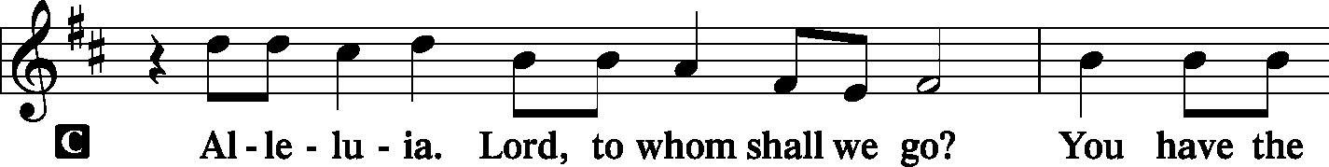
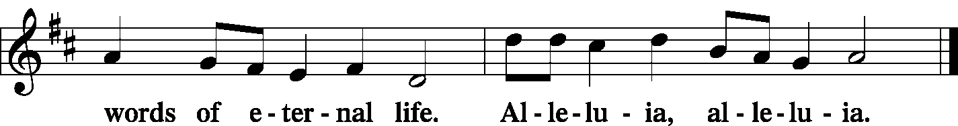

Holy Gospel John 7:37–39
P The Holy Gospel according to St. John, the seventh chapter.
C Glory to You, O Lord.

³⁷On the last day of the feast, the great day, Jesus stood up and cried out, “If anyone thirsts, let him come to me and drink. ³⁸Whoever believes in me, as the Scripture has said, ‘Out of his heart will flow rivers of living water.’” ³⁹Now this he said about the Spirit, whom those who believed in him were to receive, for as yet the Spirit had not been given, because Jesus was not yet glorified.

P This is the Gospel of the Lord.
C Praise to You, O Christ.

Nicene Creed
C I believe in one God,
the Father Almighty,
maker of heaven and earth
and of all things visible and invisible.

And in one Lord Jesus Christ,
the only-begotten Son of God,
begotten of His Father before all worlds,
God of God, Light of Light,
very God of very God,
begotten, not made,
being of one substance with the Father,
by whom all things were made;
who for us men and for our salvation came down from heaven
and was incarnate by the Holy Spirit of the virgin Mary
and was made man;
and was crucified also for us under Pontius Pilate.
He suffered and was buried.
And the third day He rose again according to the Scriptures
and ascended into heaven
and sits at the right hand of the Father.
And He will come again with glory to judge both the living and the dead,
whose kingdom will have no end.

And I believe in the Holy Spirit,
the Lord and giver of life,
who proceeds from the Father and the Son,
who with the Father and the Son together is worshiped and glorified,
who spoke by the prophets.
And I believe in one holy Christian and apostolic Church,
I acknowledge one Baptism for the remission of sins,
and I look for the resurrection of the dead
and the life T of the world to come. Amen.

Sit
Kidz’ Word
LSB 500 Creator Spirit, by Whose Aid
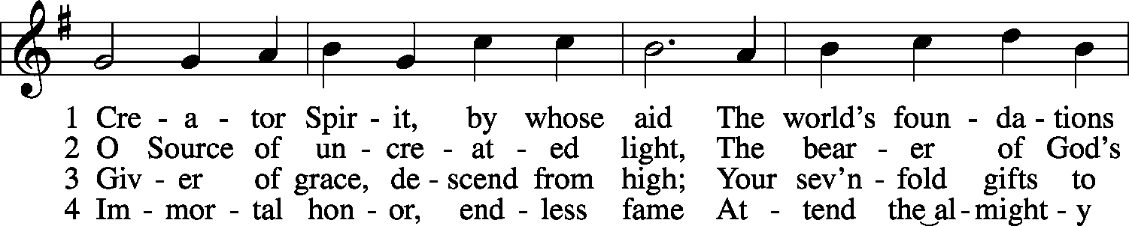
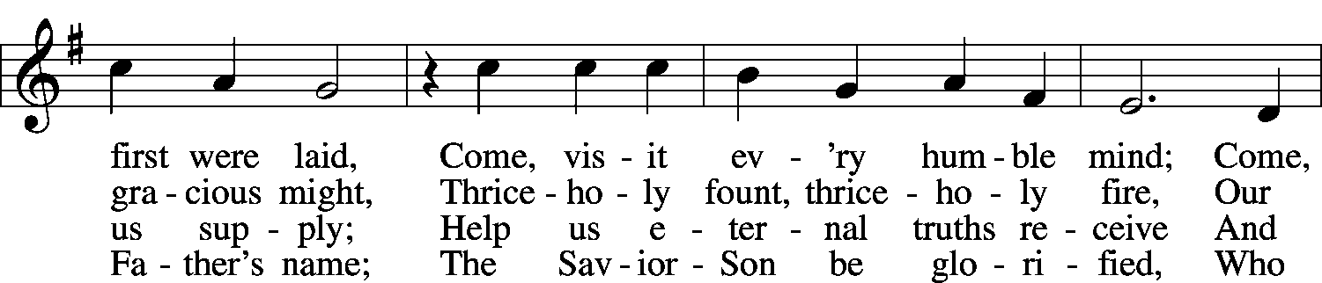
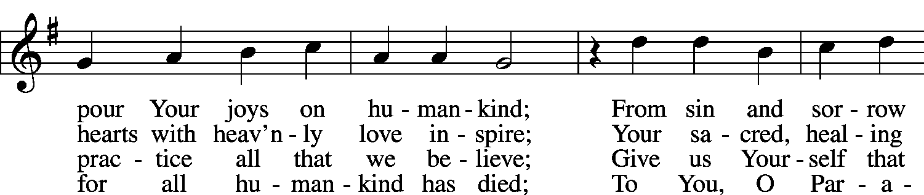
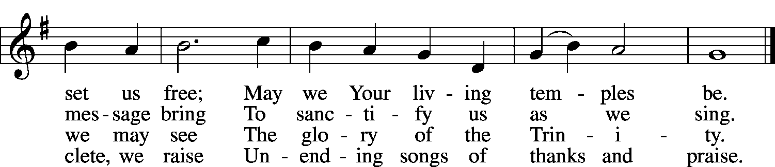
Public domain

Sermon
Stand
Prayer of the Church

Stand
Offertory LSB 159
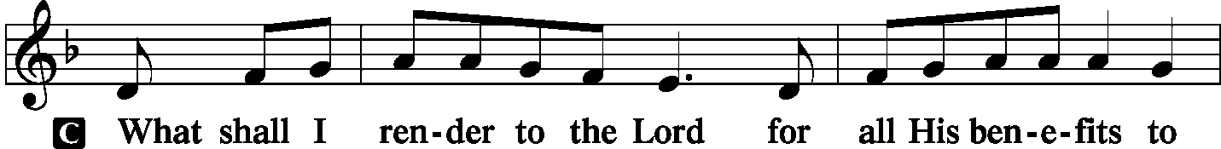
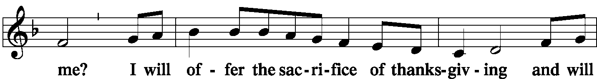
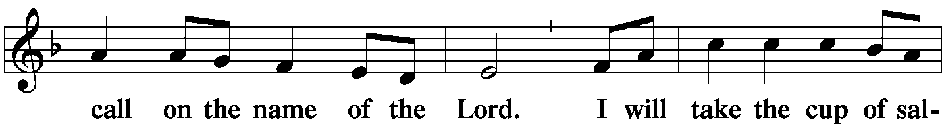
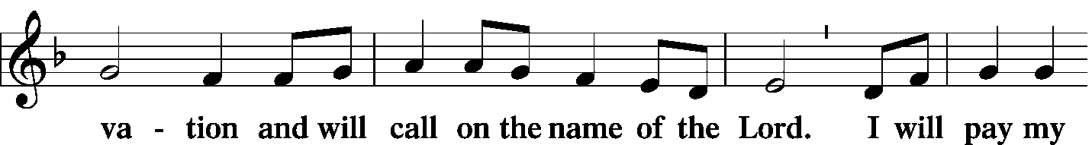
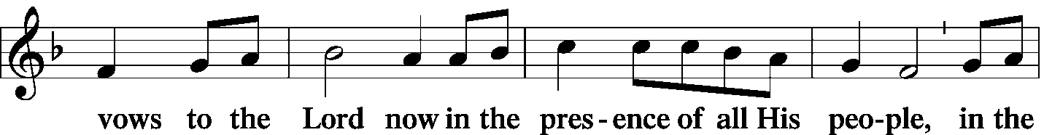
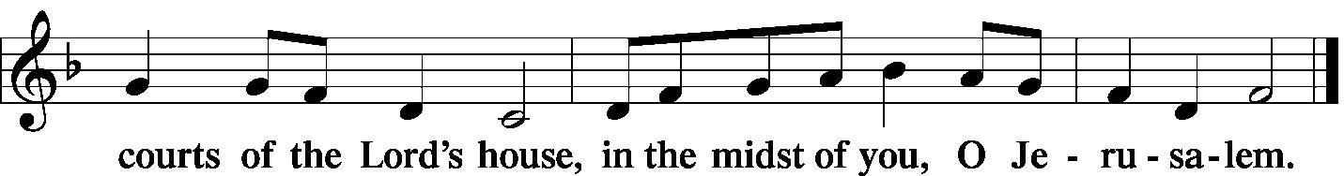

Lord's Prayer LSB 162
C Our Father who art in heaven,
hallowed be Thy name,
Thy kingdom come,
Thy will be done on earth
as it is in heaven;
give us this day our daily bread;
and forgive us our trespasses
as we forgive those
who trespass against us;
and lead us not into temptation,
but deliver us from evil.
For Thine is the kingdom
and the power and the glory
forever and ever. Amen.

Concluding Collect
P Almighty God, grant to Your Church Your Holy Spirit and the wisdom that comes down from above, that Your Word may not be bound but have free course and be preached to the joy and edifying of Christ’s holy people, that in steadfast faith we may serve You and, in the confession of Your name, abide unto the end; through Jesus Christ, our Lord.
C Amen.

Benediction LSB 166
P The Lord bless you and keep you.
The Lord make His face shine on you
and be gracious to you.
The Lord look upon you with favor and T give you peace.
C Amen.

LSB 650 Holy Spirit, Ever Dwelling
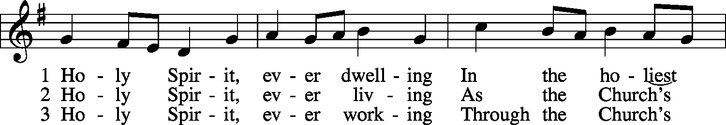
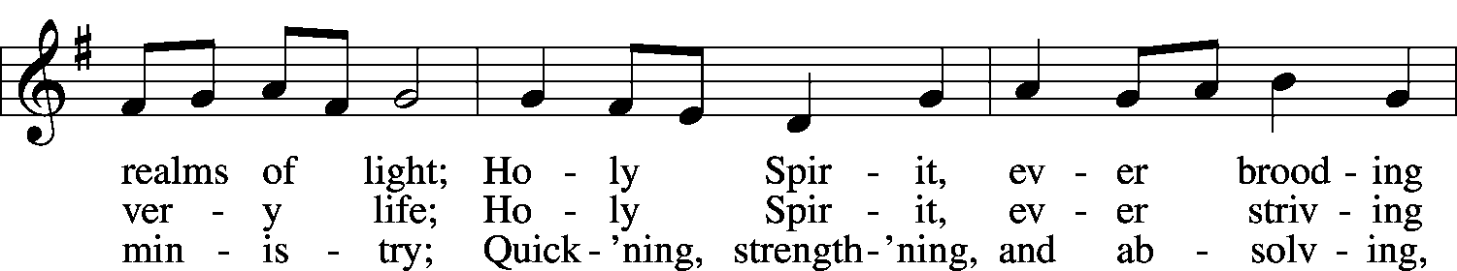
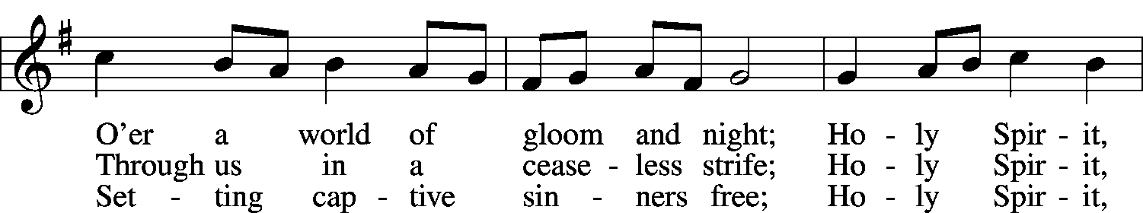
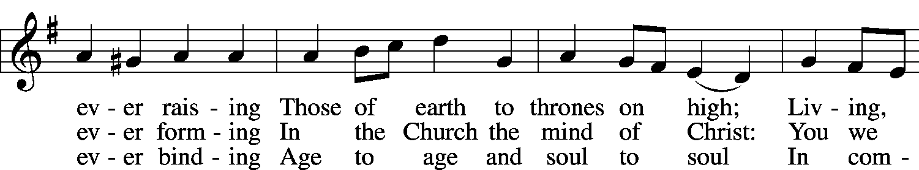
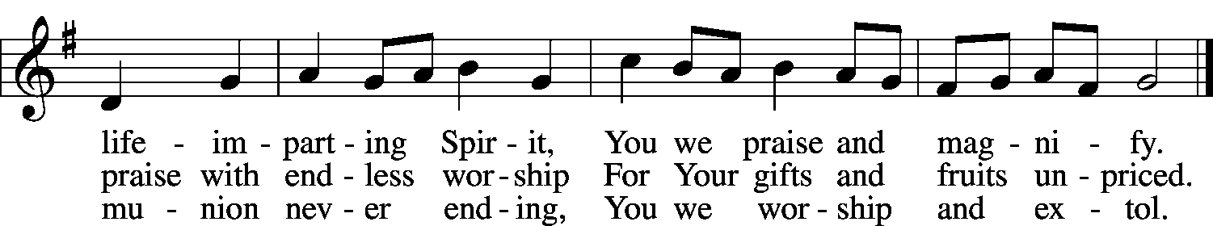
Public domain

Acknowledgments
Divine Service, Setting One from Lutheran Service Book
Unless otherwise indicated, all scripture quotations are from The Holy Bible, English Standard Version, copyright © 2001 by Crossway Bibles, a division of Good News Publishers. Used by permission. All rights reserved.
Created by Lutheran Service Builder © 2006 Concordia Publishing House.

